MOBILE NET

<ipython-input-53-25a47ec2df24>:1: UserWarning: `Model.fit_generator` is deprecated and will be removed in a future version. Please use `Model.fit`, which supports generators.

history_mobilenet = rsna_mobilenet.fit_generator( generator=train_gen_mnet,

Epoch 1/10

157/157 [==============================] - ETA: 0s - loss: 1.1278 - mae: 0.3893

Epoch 1: val_loss improved from inf to 0.09527, saving model to bone_age_mnet_weights.h5

157/157 [==============================] - 703s 4s/step - loss: 1.1278 - mae: 0.3893 - val_loss: 0.0953 - val_mae: 0.2492 - lr: 0.0010

Epoch 2/10

157/157 [==============================] - ETA: 0s - loss: 0.0501 - mae: 0.1766

Epoch 2: val_loss did not improve from 0.09527

157/157 [==============================] - 619s 4s/step - loss: 0.0501 - mae: 0.1766 - val_loss: 0.1140 - val_mae: 0.2816 - lr: 0.0010

Epoch 3/10

157/157 [==============================] - ETA: 0s - loss: 0.0422 - mae: 0.1618

Epoch 3: val_loss improved from 0.09527 to 0.04713, saving model to bone_age_mnet_weights.h5

157/157 [==============================] - 624s 4s/step - loss: 0.0422 - mae: 0.1618 - val_loss: 0.0471 - val_mae: 0.1733 - lr: 0.0010

Epoch 4/10

157/157 [==============================] - ETA: 0s - loss: 0.0408 - mae: 0.1592

Epoch 4: val_loss improved from 0.04713 to 0.04117, saving model to bone_age_mnet_weights.h5

157/157 [==============================] - 619s 4s/step - loss: 0.0408 - mae: 0.1592 - val_loss: 0.0412 - val_mae: 0.1634 - lr: 0.0010

Epoch 5/10

157/157 [==============================] - ETA: 0s - loss: 0.0352 - mae: 0.1483

Epoch 5: val_loss did not improve from 0.04117

157/157 [==============================] - 571s 4s/step - loss: 0.0352 - mae: 0.1483 - val_loss: 0.0551 - val_mae: 0.1854 - lr: 0.0010

Epoch 6/10

157/157 [==============================] - ETA: 0s - loss: 0.0323 - mae: 0.1419

Epoch 6: val_loss improved from 0.04117 to 0.03494, saving model to bone_age_mnet_weights.h5

157/157 [==============================] - 575s 4s/step - loss: 0.0323 - mae: 0.1419 - val_loss: 0.0349 - val_mae: 0.1521 - lr: 0.0010

Epoch 7/10

157/157 [==============================] - ETA: 0s - loss: 0.0341 - mae: 0.1453

Epoch 7: val_loss did not improve from 0.03494

157/157 [==============================] - 602s 4s/step - loss: 0.0341 - mae: 0.1453 - val_loss: 0.0402 - val_mae: 0.1594 - lr: 0.0010

Epoch 8/10

157/157 [==============================] - ETA: 0s - loss: 0.0321 - mae: 0.1405

Epoch 8: val_loss improved from 0.03494 to 0.03303, saving model to bone_age_mnet_weights.h5

157/157 [==============================] - 574s 4s/step - loss: 0.0321 - mae: 0.1405 - val_loss: 0.0330 - val_mae: 0.1440 - lr: 0.0010

Epoch 9/10

157/157 [==============================] - ETA: 0s - loss: 0.0302 - mae: 0.1367

Epoch 9: val_loss did not improve from 0.03303

157/157 [==============================] - 600s 4s/step - loss: 0.0302 - mae: 0.1367 - val_loss: 0.0382 - val_mae: 0.1526 - lr: 0.0010

Epoch 10/10

157/157 [==============================] - ETA: 0s - loss: 0.0308 - mae: 0.1383

Epoch 10: val_loss improved from 0.03303 to 0.02833, saving model to bone_age_mnet_weights.h5

157/157 [==============================] - 564s 4s/step - loss: 0.0308 - mae: 0.1383 - val_loss: 0.0283 - val_mae: 0.1301 - lr: 0.0010

Model: "model"

_________________________________________________________________

Layer (type) Output Shape Param #

=================================================================

input_1 (InputLayer) [(None, 224, 224, 3)] 0

conv1 (Conv2D) (None, 112, 112, 32) 864

conv1_bn (BatchNormalizatio (None, 112, 112, 32) 128

n)

conv1_relu (ReLU) (None, 112, 112, 32) 0

conv_dw_1 (DepthwiseConv2D) (None, 112, 112, 32) 288

conv_dw_1_bn (BatchNormaliz (None, 112, 112, 32) 128

ation)

conv_dw_1_relu (ReLU) (None, 112, 112, 32) 0

conv_pw_1 (Conv2D) (None, 112, 112, 64) 2048

conv_pw_1_bn (BatchNormaliz (None, 112, 112, 64) 256

ation)

conv_pw_1_relu (ReLU) (None, 112, 112, 64) 0

conv_pad_2 (ZeroPadding2D) (None, 113, 113, 64) 0

conv_dw_2 (DepthwiseConv2D) (None, 56, 56, 64) 576

conv_dw_2_bn (BatchNormaliz (None, 56, 56, 64) 256

ation)

conv_dw_2_relu (ReLU) (None, 56, 56, 64) 0

conv_pw_2 (Conv2D) (None, 56, 56, 128) 8192

conv_pw_2_bn (BatchNormaliz (None, 56, 56, 128) 512

ation)

conv_pw_2_relu (ReLU) (None, 56, 56, 128) 0

conv_dw_3 (DepthwiseConv2D) (None, 56, 56, 128) 1152

conv_dw_3_bn (BatchNormaliz (None, 56, 56, 128) 512

ation)

conv_dw_3_relu (ReLU) (None, 56, 56, 128) 0

conv_pw_3 (Conv2D) (None, 56, 56, 128) 16384

conv_pw_3_bn (BatchNormaliz (None, 56, 56, 128) 512

ation)

conv_pw_3_relu (ReLU) (None, 56, 56, 128) 0

conv_pad_4 (ZeroPadding2D) (None, 57, 57, 128) 0

conv_dw_4 (DepthwiseConv2D) (None, 28, 28, 128) 1152

conv_dw_4_bn (BatchNormaliz (None, 28, 28, 128) 512

ation)

conv_dw_4_relu (ReLU) (None, 28, 28, 128) 0

conv_pw_4 (Conv2D) (None, 28, 28, 256) 32768

conv_pw_4_bn (BatchNormaliz (None, 28, 28, 256) 1024

ation)

conv_pw_4_relu (ReLU) (None, 28, 28, 256) 0

conv_dw_5 (DepthwiseConv2D) (None, 28, 28, 256) 2304

conv_dw_5_bn (BatchNormaliz (None, 28, 28, 256) 1024

ation)

conv_dw_5_relu (ReLU) (None, 28, 28, 256) 0

conv_pw_5 (Conv2D) (None, 28, 28, 256) 65536

conv_pw_5_bn (BatchNormaliz (None, 28, 28, 256) 1024

ation)

conv_pw_5_relu (ReLU) (None, 28, 28, 256) 0

conv_pad_6 (ZeroPadding2D) (None, 29, 29, 256) 0

conv_dw_6 (DepthwiseConv2D) (None, 14, 14, 256) 2304

conv_dw_6_bn (BatchNormaliz (None, 14, 14, 256) 1024

ation)

conv_dw_6_relu (ReLU) (None, 14, 14, 256) 0

conv_pw_6 (Conv2D) (None, 14, 14, 512) 131072

conv_pw_6_bn (BatchNormaliz (None, 14, 14, 512) 2048

ation)

conv_pw_6_relu (ReLU) (None, 14, 14, 512) 0

conv_dw_7 (DepthwiseConv2D) (None, 14, 14, 512) 4608

conv_dw_7_bn (BatchNormaliz (None, 14, 14, 512) 2048

ation)

conv_dw_7_relu (ReLU) (None, 14, 14, 512) 0

conv_pw_7 (Conv2D) (None, 14, 14, 512) 262144

conv_pw_7_bn (BatchNormaliz (None, 14, 14, 512) 2048

ation)

conv_pw_7_relu (ReLU) (None, 14, 14, 512) 0

conv_dw_8 (DepthwiseConv2D) (None, 14, 14, 512) 4608

conv_dw_8_bn (BatchNormaliz (None, 14, 14, 512) 2048

ation)

conv_dw_8_relu (ReLU) (None, 14, 14, 512) 0

conv_pw_8 (Conv2D) (None, 14, 14, 512) 262144

conv_pw_8_bn (BatchNormaliz (None, 14, 14, 512) 2048

ation)

conv_pw_8_relu (ReLU) (None, 14, 14, 512) 0

conv_dw_9 (DepthwiseConv2D) (None, 14, 14, 512) 4608

conv_dw_9_bn (BatchNormaliz (None, 14, 14, 512) 2048

ation)

conv_dw_9_relu (ReLU) (None, 14, 14, 512) 0

conv_pw_9 (Conv2D) (None, 14, 14, 512) 262144

conv_pw_9_bn (BatchNormaliz (None, 14, 14, 512) 2048

ation)

conv_pw_9_relu (ReLU) (None, 14, 14, 512) 0

conv_dw_10 (DepthwiseConv2D (None, 14, 14, 512) 4608

)

conv_dw_10_bn (BatchNormali (None, 14, 14, 512) 2048

zation)

conv_dw_10_relu (ReLU) (None, 14, 14, 512) 0

conv_pw_10 (Conv2D) (None, 14, 14, 512) 262144

conv_pw_10_bn (BatchNormali (None, 14, 14, 512) 2048

zation)

conv_pw_10_relu (ReLU) (None, 14, 14, 512) 0

conv_dw_11 (DepthwiseConv2D (None, 14, 14, 512) 4608

)

conv_dw_11_bn (BatchNormali (None, 14, 14, 512) 2048

zation)

conv_dw_11_relu (ReLU) (None, 14, 14, 512) 0

conv_pw_11 (Conv2D) (None, 14, 14, 512) 262144

conv_pw_11_bn (BatchNormali (None, 14, 14, 512) 2048

zation)

conv_pw_11_relu (ReLU) (None, 14, 14, 512) 0

conv_pad_12 (ZeroPadding2D) (None, 15, 15, 512) 0

conv_dw_12 (DepthwiseConv2D (None, 7, 7, 512) 4608

)

conv_dw_12_bn (BatchNormali (None, 7, 7, 512) 2048

zation)

conv_dw_12_relu (ReLU) (None, 7, 7, 512) 0

conv_pw_12 (Conv2D) (None, 7, 7, 1024) 524288

conv_pw_12_bn (BatchNormali (None, 7, 7, 1024) 4096

zation)

conv_pw_12_relu (ReLU) (None, 7, 7, 1024) 0

conv_dw_13 (DepthwiseConv2D (None, 7, 7, 1024) 9216

)

conv_dw_13_bn (BatchNormali (None, 7, 7, 1024) 4096

zation)

conv_dw_13_relu (ReLU) (None, 7, 7, 1024) 0

conv_pw_13 (Conv2D) (None, 7, 7, 1024) 1048576

conv_pw_13_bn (BatchNormali (None, 7, 7, 1024) 4096

zation)

conv_pw_13_relu (ReLU) (None, 7, 7, 1024) 0

global_average_pooling2d (G (None, 1024) 0

lobalAveragePooling2D)

dense (Dense) (None, 1024) 1049600

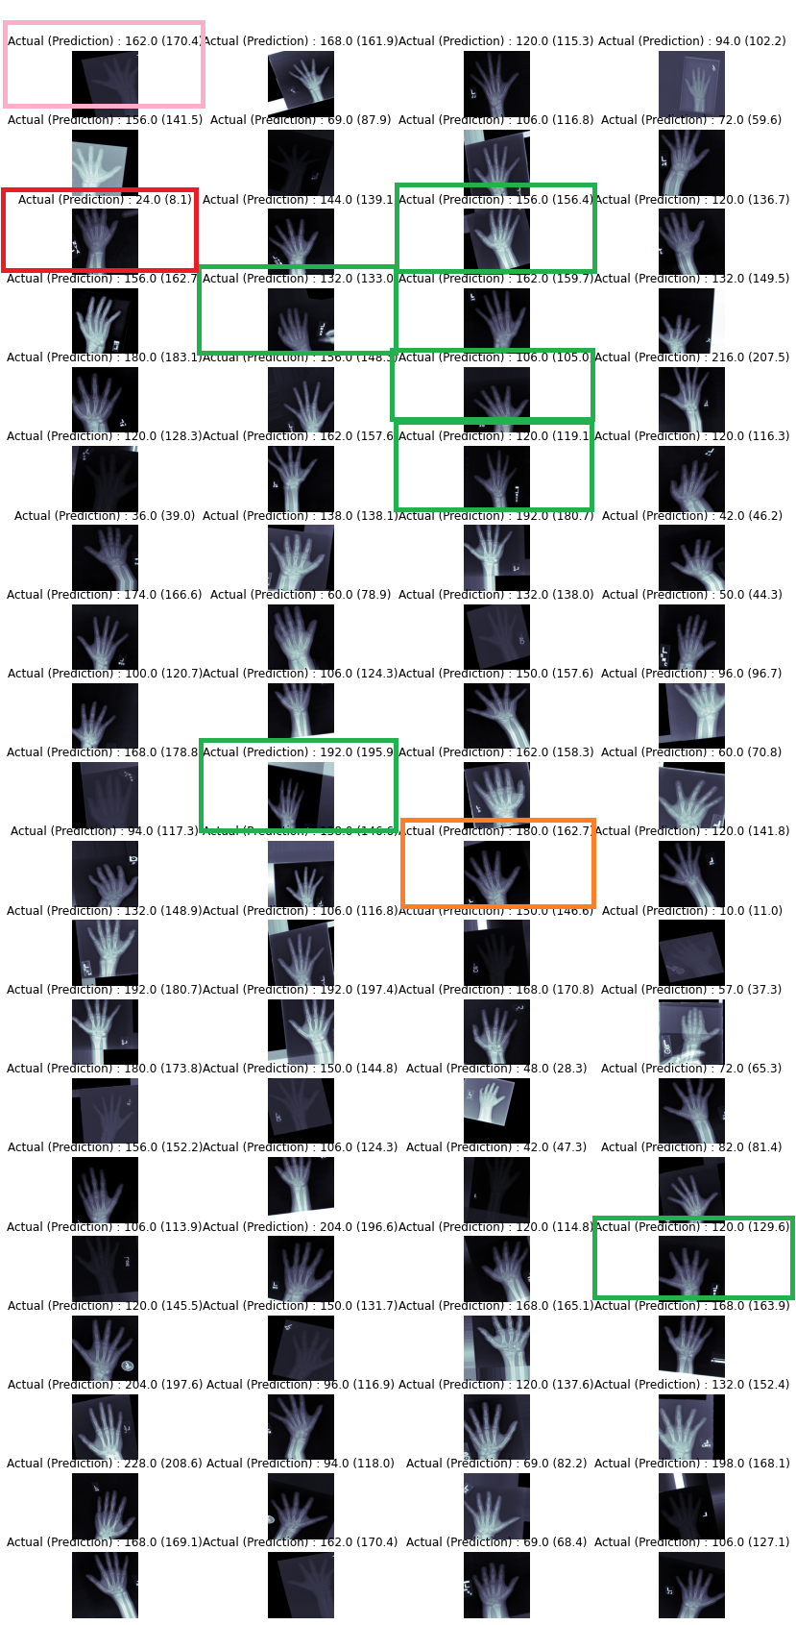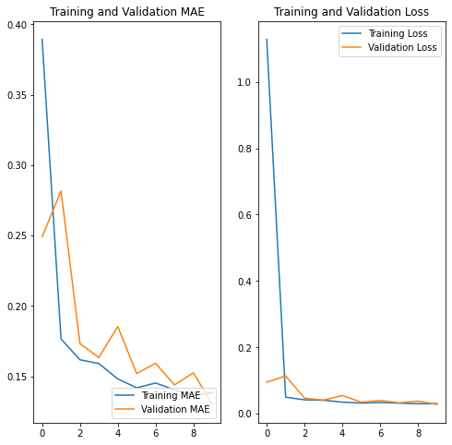

dense_1 (Dense) (None, 1024) 1049600

dense_2 (Dense) (None, 512) 524800

dense_3 (Dense) (None, 1) 513

=================================================================

Total params: 5,853,377

Trainable params: 5,817,473

Non-trainable params: 35,904

_________________________________________________________________

………………………………………………………………………………………………………………………………..

8EPOCH FROM 10 EPOCH

<ipython-input-31-25a47ec2df24>:1: UserWarning: `Model.fit_generator` is deprecated and will be removed in a future version. Please use `Model.fit`, which supports generators.

history_mobilenet = rsna_mobilenet.fit_generator( generator=train_gen_mnet,

Epoch 1/10

157/157 [==============================] - ETA: 0s - loss: 0.6375 - mae: 0.3251

Epoch 1: val_loss improved from inf to 0.16221, saving model to bone_age_mnet_weights.h5

157/157 [==============================] - 2189s 14s/step - loss: 0.6375 - mae: 0.3251 - val_loss: 0.1622 - val_mae: 0.3308 - lr: 0.0010

Epoch 2/10

157/157 [==============================] - ETA: 0s - loss: 0.0499 - mae: 0.1769

Epoch 2: val_loss improved from 0.16221 to 0.14150, saving model to bone_age_mnet_weights.h5

157/157 [==============================] - 1950s 12s/step - loss: 0.0499 - mae: 0.1769 - val_loss: 0.1415 - val_mae: 0.3132 - lr: 0.0010

Epoch 3/10

157/157 [==============================] - ETA: 0s - loss: 0.0425 - mae: 0.1622

Epoch 3: val_loss improved from 0.14150 to 0.04336, saving model to bone_age_mnet_weights.h5

157/157 [==============================] - 2029s 13s/step - loss: 0.0425 - mae: 0.1622 - val_loss: 0.0434 - val_mae: 0.1664 - lr: 0.0010

Epoch 4/10

157/157 [==============================] - ETA: 0s - loss: 0.0377 - mae: 0.1537

Epoch 4: val_loss did not improve from 0.04336

157/157 [==============================] - 1953s 12s/step - loss: 0.0377 - mae: 0.1537 - val_loss: 0.0652 - val_mae: 0.2056 - lr: 0.0010

Epoch 5/10

157/157 [==============================] - ETA: 0s - loss: 0.0362 - mae: 0.1505

Epoch 5: val_loss improved from 0.04336 to 0.03247, saving model to bone_age_mnet_weights.h5

157/157 [==============================] - 2006s 13s/step - loss: 0.0362 - mae: 0.1505 - val_loss: 0.0325 - val_mae: 0.1409 - lr: 0.0010

Epoch 6/10

157/157 [==============================] - ETA: 0s - loss: 0.0337 - mae: 0.1453

Epoch 6: val_loss did not improve from 0.03247

157/157 [==============================] - 2021s 13s/step - loss: 0.0337 - mae: 0.1453 - val_loss: 0.0336 - val_mae: 0.1410 - lr: 0.0010

Epoch 7/10

157/157 [==============================] - ETA: 0s - loss: 0.0317 - mae: 0.1402

Epoch 7: val_loss did not improve from 0.03247

157/157 [==============================] - 2003s 13s/step - loss: 0.0317 - mae: 0.1402 - val_loss: 0.0470 - val_mae: 0.1699 - lr: 0.0010

Epoch 8/10

157/157 [==============================] - ETA: 0s - loss: 0.0306 - mae: 0.1378

Epoch 8: val_loss did not improve from 0.03247

157/157 [==============================] - 1986s 13s/step - loss: 0.0306 - mae: 0.1378 - val_loss: 0.0361 - val_mae: 0.1499 - lr: 0.0010

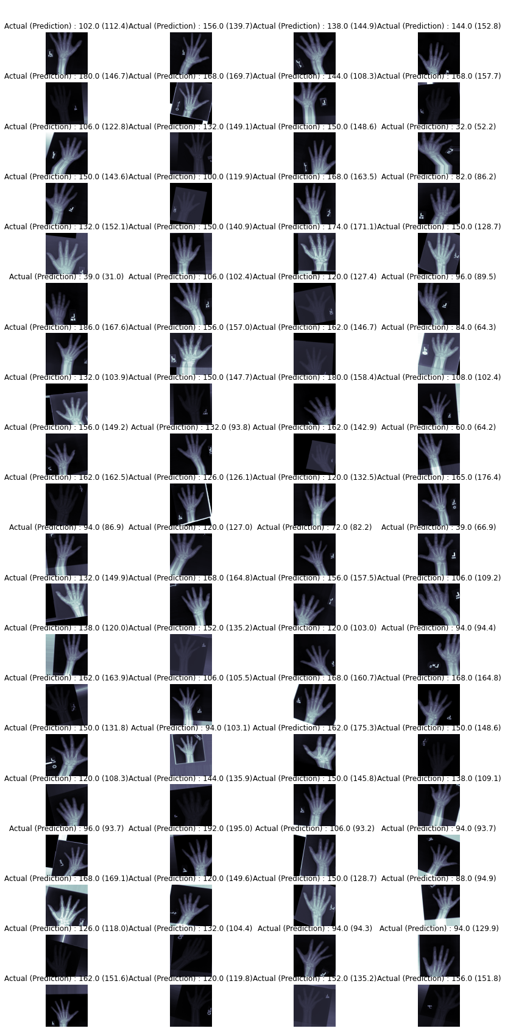

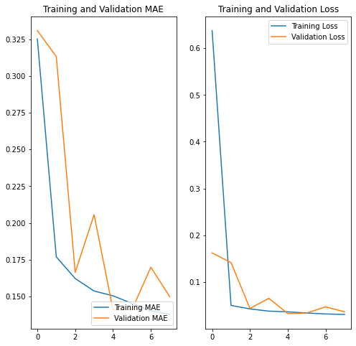

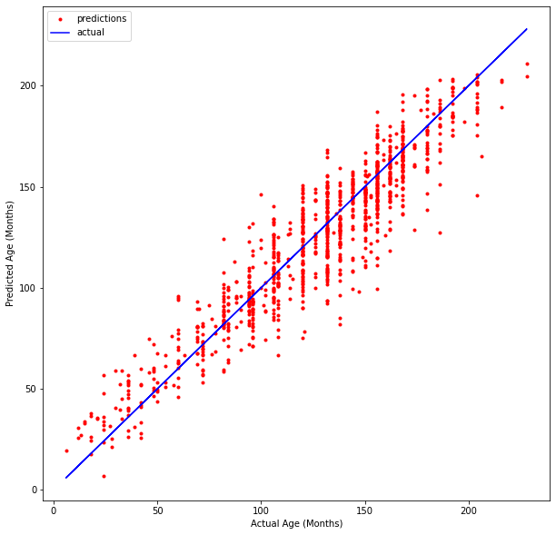

**print('Test: %.3f' % (pred_acc)) Test: 0.395**

………………………………………………………………………………………………………………………………………………………………………………………………

6 EPOCHS

<ipython-input-73-371dbd4e7d73>:1: UserWarning: `Model.fit_generator` is deprecated and will be removed in a future version. Please use `Model.fit`, which supports generators.

history_mobilenet = rsna_mobilenet.fit_generator( generator=train_gen_mnet,

Epoch 1/6

157/157 [==============================] - ETA: 0s - loss: 0.0362 - mae: 0.1508

Epoch 1: val_loss did not improve from 0.03247

157/157 [==============================] - 1966s 12s/step - loss: 0.0362 - mae: 0.1508 - val_loss: 0.0438 - val_mae: 0.1629 - lr: 0.0010

Epoch 2/6

157/157 [==============================] - ETA: 0s - loss: 0.0325 - mae: 0.1423

Epoch 2: val_loss improved from 0.03247 to 0.03120, saving model to bone_age_mnet_weights.h5

157/157 [==============================] - 1936s 12s/step - loss: 0.0325 - mae: 0.1423 - val_loss: 0.0312 - val_mae: 0.1391 - lr: 0.0010

Epoch 3/6

157/157 [==============================] - ETA: 0s - loss: 0.0324 - mae: 0.1417

Epoch 3: val_loss did not improve from 0.03120

157/157 [==============================] - 1938s 12s/step - loss: 0.0324 - mae: 0.1417 - val_loss: 0.0449 - val_mae: 0.1665 - lr: 0.0010

Epoch 4/6

157/157 [==============================] - ETA: 0s - loss: 0.0298 - mae: 0.1354

Epoch 4: val_loss did not improve from 0.03120

157/157 [==============================] - 2010s 13s/step - loss: 0.0298 - mae: 0.1354 - val_loss: 0.0359 - val_mae: 0.1490 - lr: 0.0010

Epoch 5/6

157/157 [==============================] - ETA: 0s - loss: 0.0295 - mae: 0.1350

Epoch 5: val_loss did not improve from 0.03120

157/157 [==============================] - 1958s 12s/step - loss: 0.0295 - mae: 0.1350 - val_loss: 0.0462 - val_mae: 0.1673 - lr: 0.0010